Teach Yourself Guitar Overnight: Lesson 2
Introduction to Playing Guitar Chords

Welcome back!
So you’ve been through Lesson 1. You’ve learned how to read and play ‘Guitar TAB’. You also know how to play ‘Smoke on the Water’ and the ‘Major Scale’! Congratulations!!! That was your first step toward great guitar playing and you should be proud of yourself.
Let’s move forward shall we?

Guitar Chords…What are they?

I’m sure you’ve heard the term before, but what does it mean? What is a chord?
We learned that a ‘note’ or a ‘musical tone’ is basically any sound that a guitar would make. It is a definite pitch defined by a frequency of sound. The science of it is not really that important for this lesson but when you put notes together you make music! This is called a melody. Notes being played in a ‘progression’ (one after another) produces a melody…while notes played ‘at the same time’ or on top of eachother is a chord. If you tried just playing any three (or more) notes together you wouldn’t necessarily be playing a chord and it might not sound too pretty! So, to sum it up a chord is three or more notes played at the same time ‘in harmony’ meaning they sound good together!

Why are Chords Important?

Chords are very important in music, and extremely important in guitar music.
When you hear someone playinga song on the guitar and singing along, they are playing chords in the background to fill in the ‘rhythm’ section of the song. Most songs –even classical music- consist of a ‘Melody Line’ and a ‘Chord Progression’. For example, in modern music the melody line would be “Wild thing, you make my heart sing” while the chords are being strummed in the background.
In classical music, the left hand on the piano or the ‘rhythm’ section of an orchestra would play the ‘chord progression’ while the main lead instrument or the right hand on the piano, would play the main melody line. (Most likely what will stick in your head!)

How do I play chords?

There are 5 ‘open’ chords on the guitar. They are called ‘open chords’ because some of the notes in these chords are played as open strings that you don’t have to put fingers on frets to accomplish. That does not mean that the entire chord is just all open strings! Just a few notes of each of these 5 chords are open.
These chords are E, A, D, G and C.
Let’s learn ‘em!
We remember the guitar ‘TAB’ setup right?

_____________________________________________ String #1–High String
_____________________________________________
T____________________________________________ A____________________________________________
B____________________________________________
_____________________________________________ String #6-LOW String

*REMEMBER: The Top line is the highest sounding string that is closest to the floor when playing the guitar. The Bottom line is the LOW (thickest) String on the guitar.*

This is the ‘TAB’ for an ‘Open E’ Chord, a very common chord on the guitar.
NOTE: The 0’s mean to play that string OPEN without holding down any frets.

____0_________________________________________ ____0_________________________________________
T___1_________________________________________ A___2_________________________________________
B___2_________________________________________
____0_________________________________________

Notice how the notes are stacked on top of eachother? This means to PLAY THEM AT THE SAME TIME! When they are written from left to right, then you play them one after the other….thus creating a melody line. When they are stacked, they are played at the same time thus creating a ‘CHORD’!

So for this chord, you only have to hold down fret #2 on the two strings below the lowest string….I suggest using your middle finger for the first one and ring finger for the next, then you realize that the next string says fret #1 and your index finger is conveniently right there! It is always important to consider the best fingering for chords as they will help you play them easily and transition between them faster.

Here is a picture of someone playing an ‘Open E’ Chord! to give you a little bit more help!

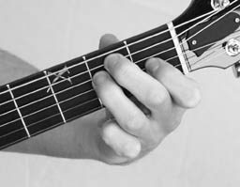

ANOTHER TIP: Try to imagine making as much of a ‘claw’ as you can with your fingers so that none of your fingers touch the other strings. This can mute those notes and is a very common mistake people make when first starting to play guitar chords.
Only 3 frets are being held down here and 3 strings are being played ‘open’. Hopefully now you fully understand what an open chord is and have some ease playing this E chord. This is not a beginner chord and is VERY Popular in all styles of music particularly rock ‘n’ roll and blues.

Let’s Learn the Rest of the Open Chords!

Ok, if you insist!
The next open chord we will learn is the ‘open G’ Chord.

____3_________________________________________ ____0_________________________________________
T___0_________________________________________ A___0_________________________________________
B___2_________________________________________ ____3_________________________________________

Yes, this one has 3 open strings in it as well. This is another really popular chord on the guitar. The 3rd fret on the bottom line (lowest string) should be played with your middle finger, followed by the 2nd fret of the very nect string played with index finger. Then you skip 3 strings and leave them open! The high string (closest to the floor) you play the 3rd fret with your ring or pinky finger which ever one is easier for you!

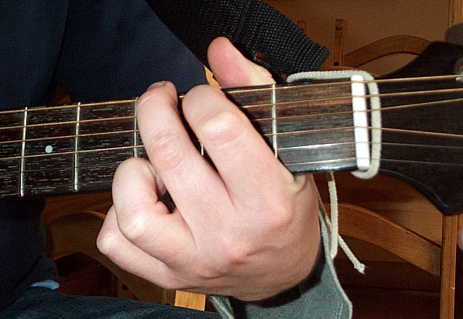

The Next open chord we will learn is the C Chord.
This chord has 2 open strings in it and one string that doesn’t get played at all!
This is common and you will see it with a few chords.

_______0______________________________________ _______1______________________________________
T______0______________________________________ A______2______________________________________
B______3______________________________________ _____X________________________________________

NOTE: The ‘X’ on the LOW String means DO NOT PLAY THAT STRING!
Simply start your strum on the next string, the one with the 3rd fret being held down.

Use your Ring finger for the 3rd fret. Then your middle finger for the 2nd fret on the next string. Skip a string (this one is played open) and place your index finger on the 1st fret of the second to last string. Finally, the last string is played open.
Here is a BIG Picture of a ‘C Chord.’

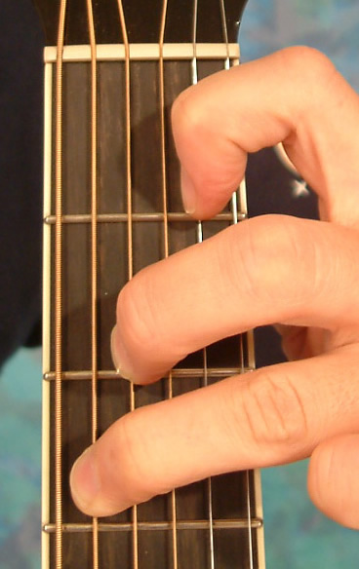
I know this is a big picture but at least it will help you!!

TWO MORE CHORDS TO GO!!

Open ‘A’ Chord:

_____0________________________________________ _____2________________________________________
T____2________________________________________ A____2________________________________________
B____0________________________________________
_____X________________________________________

This chord is fairly easy…the bottom string is not played like in the C Chord. Then we have an open string followed by the 2nd fret on three strings in a row! Finally, an open string at the top.

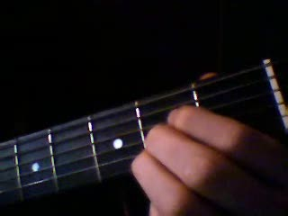

The Lowest String is NOT Played or Strummed.
The index finger is on the 2nd fret of the second string, followed by the middle finger and then the ring finger, ALL on the 2nd fret of three strings in a row. The top string is played open (string closest to the floor).

LAST BUT NOT LEAST!

The ‘D Chord’ will be our final Open Chord on the guitar. You’ll be amazed at how far you can go with just these 5 chords!

Open D Chord:

______2_______________________________________ ______3_______________________________________
T____2________________________________________ A____0________________________________________
B____X________________________________________
_____X________________________________________

This chord has TWO strings that are NOT Played at all.
The two LOWEST strings. (this means that when strumming the chord with the right hand you will start on the string that says 0, you will not strum every string on the guitar like the first two chords.
The next string is played open, followed by your index finger on the 2nd fret and then your RING finger on the 3rd fret of the next string. Finally, your middle finger on the 2nd fret of the top string (closest to floor).

Picture of Open ‘D’ Chord:

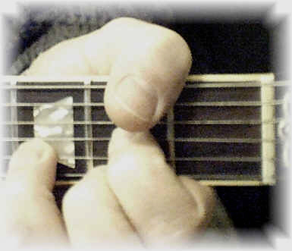
Open D Chord.

There you have it! You have learned how to play chords on the guitar, as well as learning all 5 open chords! Again, these are NOT beginner chords, these are professional level guitar chords that are used daily by guitarists and rock ‘n’ rollers all over the world! These are actually the most commonly used chords on the guitar and the most popular! Go out and get yourself a songbook of your favorite artist for guitar! Most ALL songbooks have the Letter of the chord written right above the lyrics so you can follow along and learn the rhythm for your favorite songs just by reading “G, or C, or E, etc…” You can also find the chords to many of your favorite songs by simply Googling ‘Guitar Chords for _________ song.’ They are not always 100% correct but you will be able to tell if it is way off and you’ll also get some great free practice material!

This was Lesson #2 of a two-part lesson titled ‘Teach Yourself Guitar Overnight!’ I do have a third, separate lesson on the way that takes you even further into guitardom. The chords you learned in this lesson are all ‘Major’ Chords. In the next lesson, you will learn the ‘Minor’ Chords as well as the difference between Major and Minor chords. Also, we will begin to play songs using chords.

Thank you for reading ‘Teach Yourself Guitar Overnight! Lesson 2’

